Základnou jednotkou obsahu je ${1m}^{2}$ – jeden štvorcový meter (obsah štvorca so stranou dĺžky $1m$).
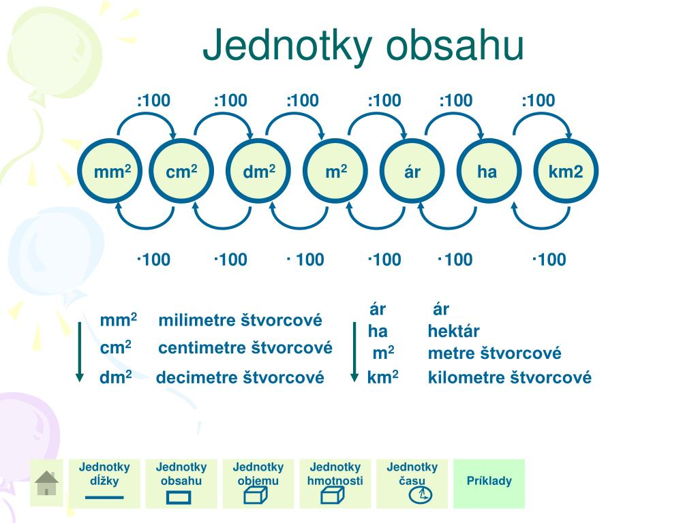

Príklad: Premeňte na jednotky uvedené v zátvorke:
- $11m^{2}\left({cm}^{2}\right)=$
- $9842mm^{2}\left({dm}^{2}\right)=$
Riešenie:
- $11m^{2}\left({cm}^{2}\right)=11.100.100=110 000{cm}^{2}$
- $9842mm^{2}\left({dm}^{2}\right)=9842:100:100=0,9842{dm}^{2}$
Samostatná úloha: Premeňte na jednotky uvedené v zátvorke:
- $7{dm}^{2} \left({dm}^{2}\right)=$
- ${45,16m}^{2} \left(a\right)=$
- $942 148 a \left({km}^{2}\right)=$
- $7122{cm}^{2} \left(m^{2}\right)=$
- $201,001a \left(ha\right)=$
- ${12,9dm}^{2} \left({cm}^{2}\right)=$
- ${0,002km}^{2} \left(a\right)=$
- $0,003{km}^{2 }\left(ha\right)=$
- $0,112 {dm}^{2} \left({mm}^{2}\right)=$
- $5,08{dm}^{2} \left({cm}^{2}\right)=$
- $31ha \left({dm}^{2}\right)=$
- $9842{mm}^{2} \left({dm}^{2}\right)=$
- $125000mm^{2}\left({cm}^{2}\right)=$
- $114,3a \left(m^{2}\right)=$
- $2047{dm}^{2} \left(a\right)=$
- $93,31ha \left(m^{2}\right)=$
- $0,000061{km}^{2}\left(m^{2}\right)=$
- ${8122cm}^{2}\left({dm}^{2}\right)=$
- $25148000{mm}^{2} \left(a\right)=$
- $773ha \left({km}^{2}\right)=$
- $29ha \left(a\right)=$
- $1600m^{2} \left(ha\right)=$
- $41,5{dm}^{2} \left(m^{2}\right)=$
- $0,805a \left({cm}^{2}\right)=$
- $5511,02{cm}^{2} \left({dm}^{2}\right)=$
- $12995000m^{2}\left({km}^{2}\right)=$

